Overview:

Objective is to make a car seat heater. The whole project is divided in to four different activities.

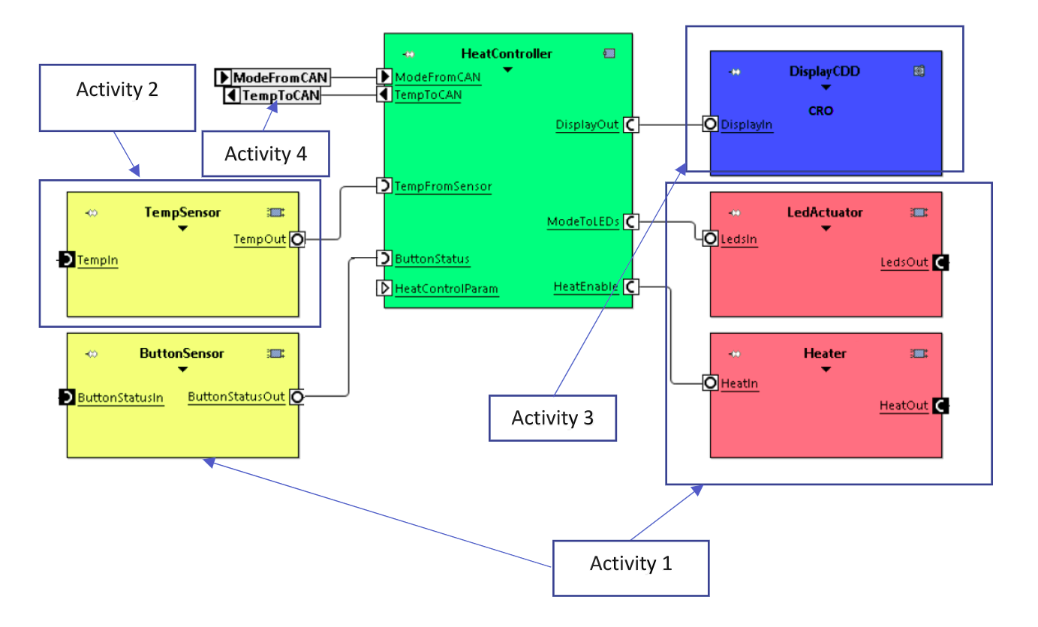

Activity 1

To check the status of passenger whether seated or not and show the status , then to check whether heater is on or not . If both the conditions are satisfied the LED will glow.

Activity 2

To take the ADC value of temperature sensor as input to microcontroller.

Activity 3

To display the temperature by showing output PWM through CRO.

Activity 4

To show the temperature input to CAN module, which shows the temperature values gone to protocol.

Simulation Schematic and Output

Case 1: When Button sensor Switch or Heater Switch or both are OFF

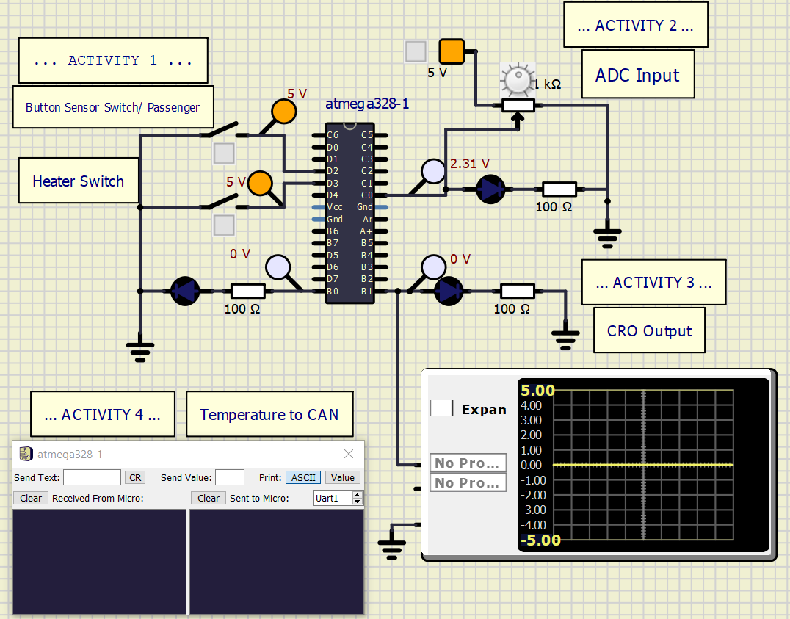

Case 2: When Button Sensor is ON and Heater Switch is OFF

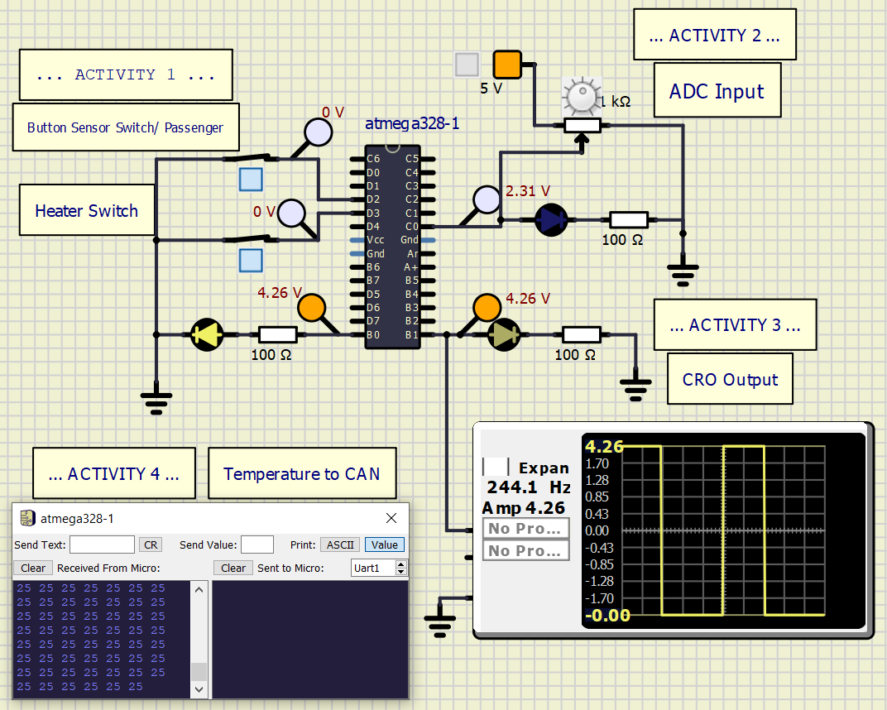

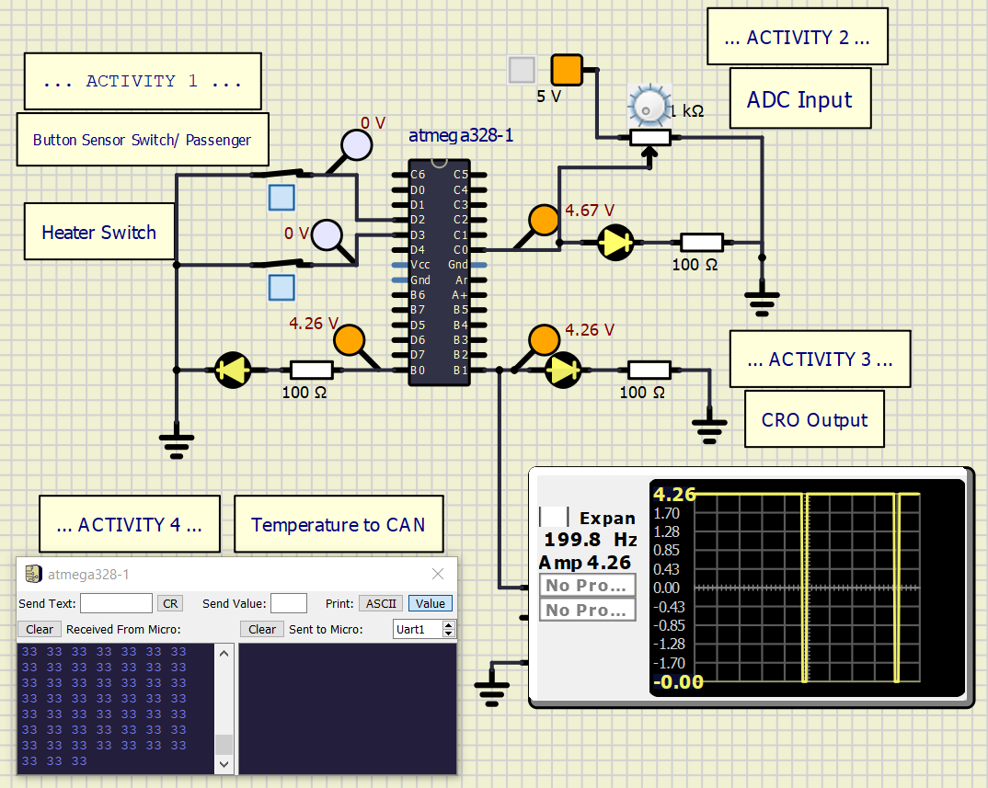

Process to Build the project

1. In case of codeblocks find the ZIP folder named “302457_Embedded_Casestudy_Codeblocks” inside repository.

->Open “302457_Embedded_Casestudy_codeblocks” then click “view raw’, the ZIP folder will be downloaded.

->Then unzip it and open this project in codeblocks.

->Build the project, you will get ‘.hex’ file in “bin” folder.

2. In Visual Studio download the ZIP folder of repository and then unzip it.

-> Open this repository in vscode.

-> Change the working directory to “Implementation_Codefiles”.

-> Run the ‘make’ file in ubuntu WSL terminal.

-> Hex and elf files will be generated inside “Implementation_Codefiles >> Build folder”.